TASK SHEET
Year: 11 General English
Topic: Feature Film Study Task 2

Topic:

Student: Teacher: Date Due: Term 1 Week 8

Achievement Standards:
Receptive Modes: (reading, writing, viewing)
Productive Modes: (writing)
Achievement Standard focused on:
- Writing - responding
Time allocation: 4 periods
Conditions: In class development of a response to a feature film

Weighting: 10%

Mark: / 20

Teacher Comment:

Task
After viewing and discussing the issues presented in the feature film, you are required to plan and draft responses to a series of extended questions to create a written response in well organised paragraphs
You will :
- take notes during the viewing of the movie and produce a written response through a series of short and extended questions.
- examine how visual language is used to influence readers and target particular audiences through viewing and deconstructing a feature film.
- focus on how characters and subjects are represented a particular way and the values and attitudes conveyed to the audience.
- read a variety of supplementary materials including various blogs and reviews of the movie, extracting and critically examining these texts for purpose, contexts and use of persuasive language.

Self-reflection
What three things did I do well?
What three things could I have done better?
What things could I do in class to help me improve for the next task?
What things could I do at home to help me improve for the next task?

ASSESSMENT CRITERIA |  | Total  Marks | Your  Mark
Use information for specific purposes and contexts  Qs 1,2, 3 | - Extracts relevant and detailed information from the film and information provided to answer the questions in the response. Critically questions any supplementary reviews of the movie to identify the purpose and techniques used to influence the viewer. | 15-20
 | - Extracts mostly relevant and quite detailed information from the film and information provided to answer the questions in the response. Questions reviews of the movie to identify the purpose and techniques used to influence viewers. | 13-14
 | - Extracts some relevant information from the film and information provided to answer the questions in the response. Can identify the purpose and contexts of texts and viewers in a simplistic way using reviews and other sources | 10-13
 | - Much of the relevant and detailed information from the film is not used to answer the questions in the response. Reads reviews literally and does not identify the purpose or context of the information. | 7-9
 | - Does not use the supplementary reviews and material provided by the teacher at all | 0-6
Consider the ways in which texts communicate ideas, attitudes and values  Qs 4, 5, 6, 7, 8 | - Clearly explains the way film codes and conventions are used to communicate information and influence audiences about characters or values, attitudes and issues. | 30-40
 | - Generally explains the way film codes and conventions are used to communicate information and influence audiences about characters or values, attitudes and issues | 26-31
 | - Attempts to explain the way film codes and conventions are used to communicate information and influence audiences about characters or values, attitudes and issues with some success | 20-25
 | - Provides little explanation of how film codes and conventions are used to communicate information and influence audiences about characters or values, attitudes and issues | 14-19
 | - Provides no explanation of how film codes and conventions are used to communicate information and influence audiences about characters or values, attitudes and issues | 0-13
Use strategies and skills for comprehending texts  Qs 4, 5, 6, 7, 8 | - Consistently supports their ideas with a large range of relevant and specific examples, facts and details from the film that promote a deeper understanding of the text through analysis of text structure, language and visual cues. | 25-30
 | - Usually supports their ideas with many relevant and specific examples, facts and details from the film facts and details from the film that promote a deeper understanding of the text through analysis of text structure, language and visual cues. | 20-24
 | - Sometimes supports their ideas with some relevant and specific examples, facts and details from the film facts and details from the film that promote some understanding of the text through analysis of text structure, language or visual cues. | 14-19
 | - Provides a few relevant examples from the film to support their ideas. Answers lack clarity and depth. | 7-13
 | - Provides little or no examples from the film to support their ideas | 0-6
Language control | - Has exceptional control of language conventions such as vocabulary, spelling, grammar and punctuation | 9-10
 | - Has very good control of language conventions such as vocabulary, spelling, grammar and punctuation | 7-8
 | - Has satisfactory control of language conventions such as vocabulary, spelling, grammar and punctuation | 5-6
 | - Has little control of language conventions such as vocabulary, spelling, grammar and punctuation | 3-4
 | - Has no control of language conventions such as vocabulary, spelling, grammar and punctuation | 0-2
TOTAL MARKS |  | 100
The following can be used as a guide to your response
INTRODUCTION:
- Briefly outline the story (plot) and main focus of the film.
- Where and when was the movie made?
- Is the film based on fiction or non-fiction? Explain.
Paragraph 2: DIRECTOR AND ACTORS
- Introduce the director’s name and any of the movies they may be known for.
- State the main characters involved. Place actors’ names in brackets after the characters’ names. eg Jack Sparrow ( Johnny Depp)
- How convincing were the actors in their roles?
Paragraph 3: SETTING AND LOCATION
- Describe the main setting(s) and their importance to the plot.
Paragraph 4: AUDIO CODES
- How are audio codes (eg dialogue, music and sound effects) used to enhance the mood of a scene?
- Give at least one specific example and explain the impact it has on the audience:
Paragraph 5: CHARACTER: PROTAGONIST
- How does the director encourage viewers to respond to the main character (protagonist)?
- Give an example or two to support your answer, discussing at least two specific film codes (eg. costume, dialogue, camera shots, angles, symbols, props and lighting):
Paragraph 6 : ISSUES, VALUES AND ATTITUDES
- Discuss the values and attitudes that are promoted by the film towards a particular issue:
Paragraph 7: CONCLUSION
- Do you think the film is inspirational?
- Does the film reflect attitudes in our society today?
- Who would you recommend this film to and why?

Editing
Check that you’ve
- Included all the contents
- Provided evidence in every case
- Used complete sentences and clear paragraphs
- Correct spelling
You may plan your response here, using these graphic organisers


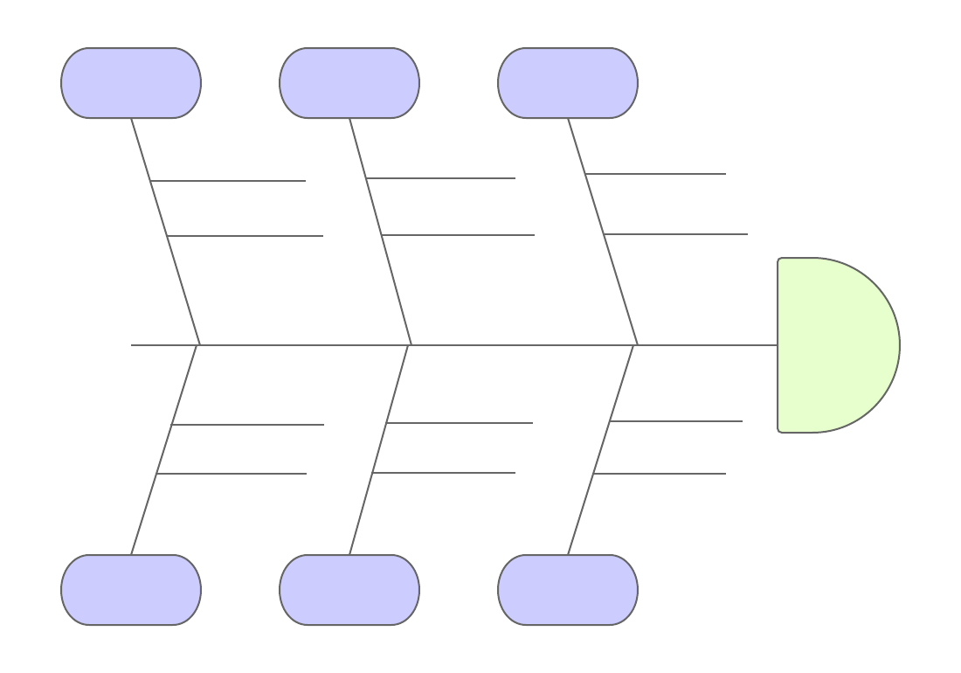


Event | Inference – what does it prove

Write your answer/response here

